SQL Practice: EZ Health & ABC Furniture

EZ Health

The health system is comprised of many hospitals. Hospitals are identified by a unique id, they have a name, and a date of establishment. Each hospital has many doctors and nurses. Doctors work at multiple hospitals, however nurses are assigned specific hospitals and are only allowed to work there. Doctors and nurses have their own unique identifiers, names, DOB, schools they went to. Each nurse needs to be supervised by at least one doctor. Doctors can supervise many nurses and are not required to supervise them as well. Patients visit multiple doctors and do not need to visit a doctor. Doctors look after several patients. Patients also visit nurses as a pre-checkup, and they have only one assigned nurse. A nurse can provide healthcare support to many patients.
Help EZ health with the following

- Build a conceptual model
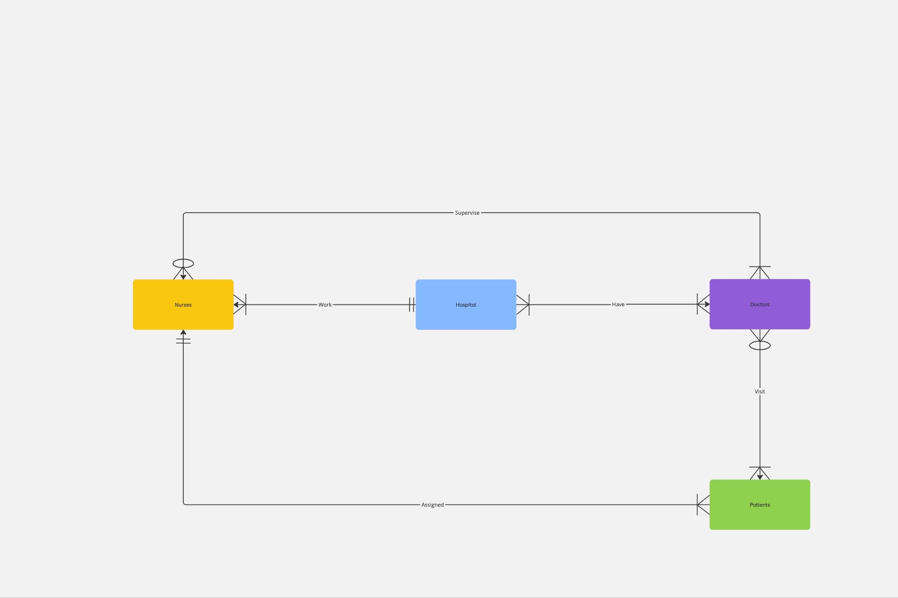

- Resolve the relationships if needed
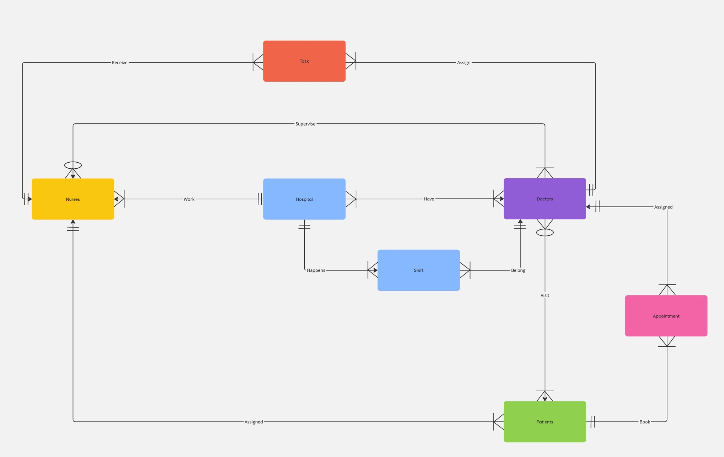

- Build the logical mode 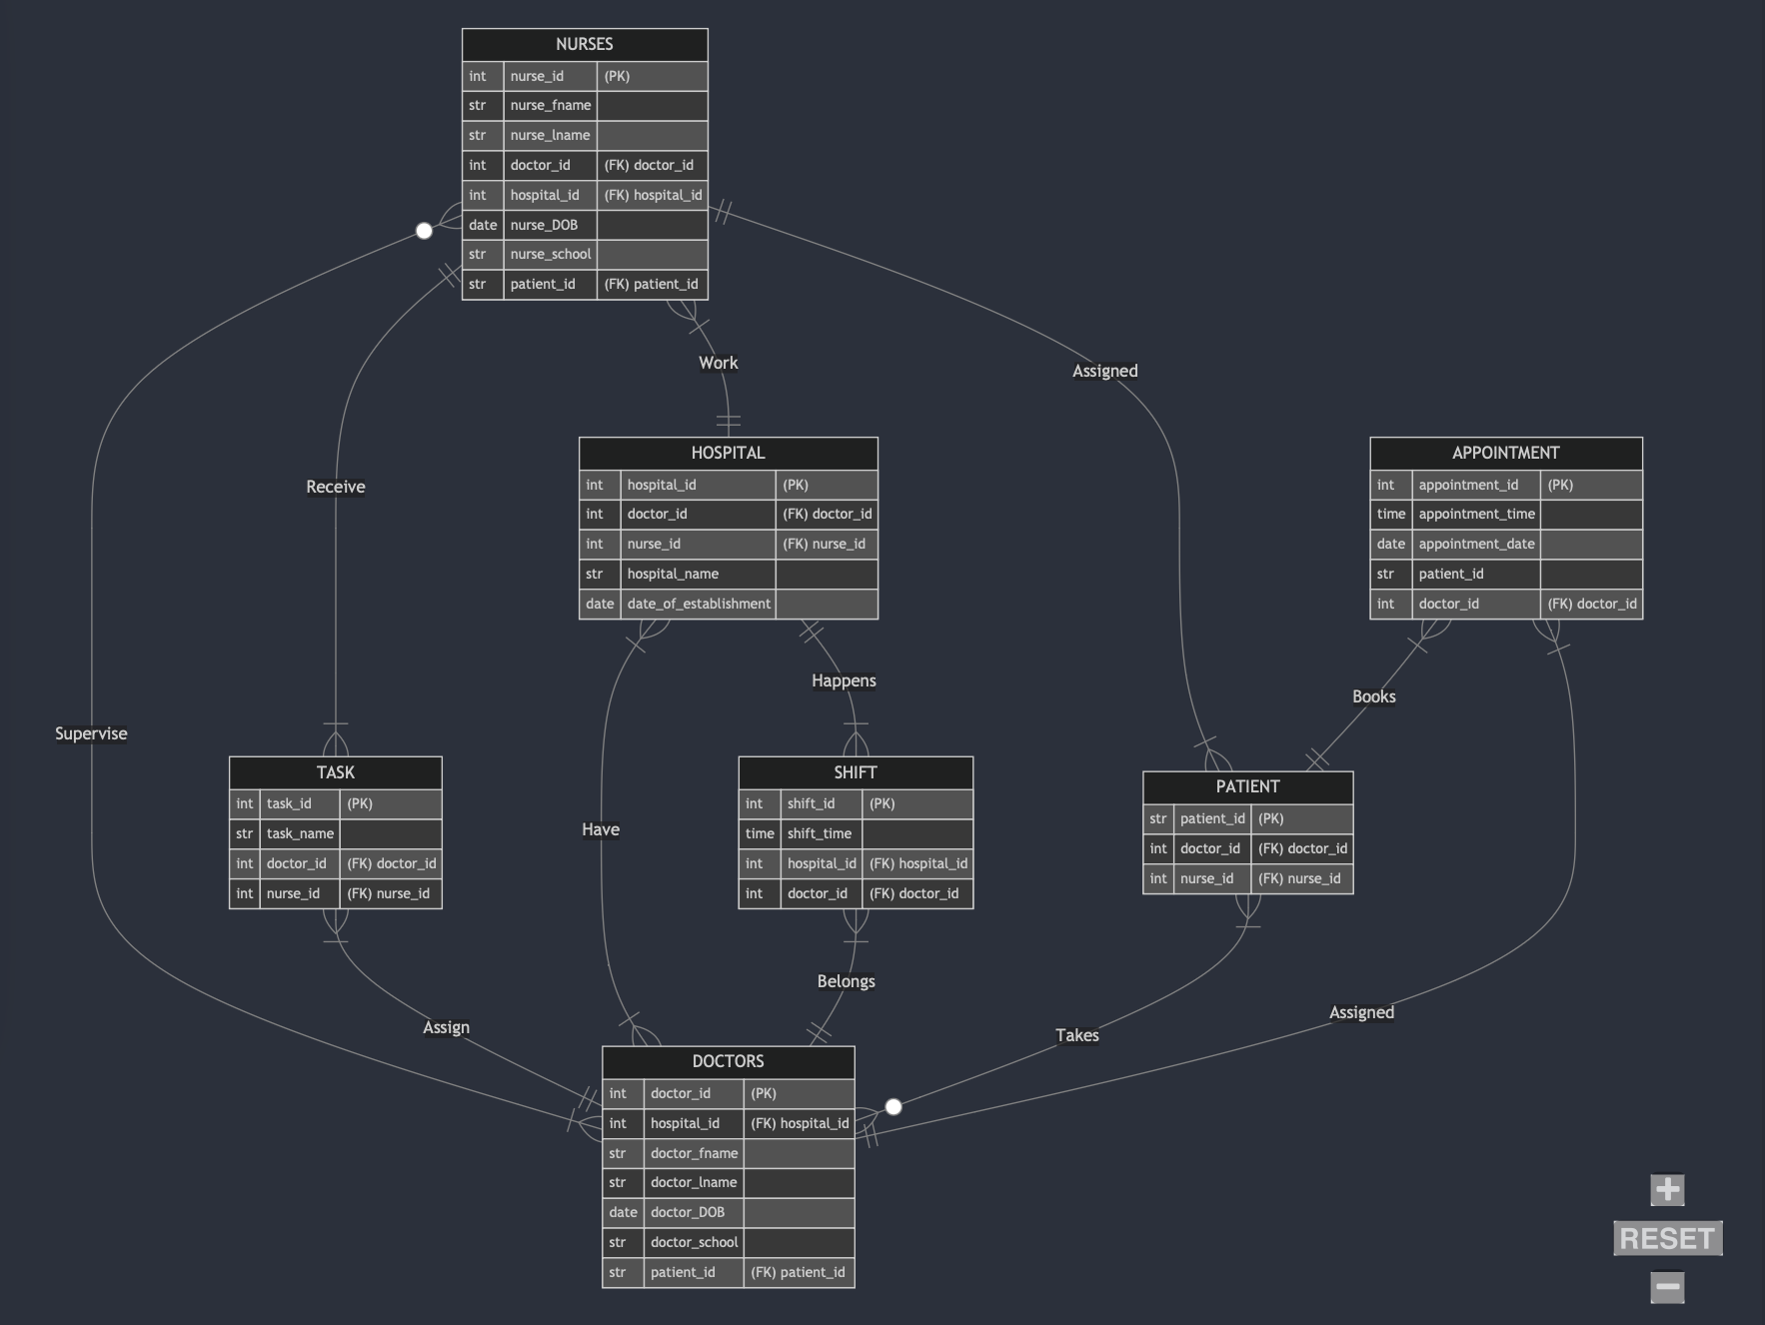

- Normalize the schema to 1NF, 2NF and 3NF, explain your rationale
The schema is already in 1NF, since all the tables in the schema have atomic attributes, and no multivalued attributes are evident. Also, primary keys are specified, ensuring uniqueness of rows.
Each table has a single-column primary, there are no composite keys that might cause partial dependency. Non-prime attributes in each table are directly dependent on the primary key of their respective table. So, the schema satisfies 2NF.
Finally, there are no transitive dependencies where one non-prime attribute depends on another non-prime attribute, satisfying 3NF.

Questions

1. What would happen if we removed the NOT NULL constraint from Patient's assigned_nurse_id?
Patients could exist in the database without being assigned a nurse. This could lead to inconsistencies, such as a situation where care-related processes that depend on nurse assignments fail. This would also make it impossible to enforce that every patient has a nurse.
2. How does the model enforce that nurses work at only one hospital while doctors can work at many?
In the NURSES table, hospital_id Is linking each nurse to a specific hospital. Since this is not a multivalued attribute, each nurse can only work at one hospital at a time. On the other side, the SHIFT table links doctors to hospitals via the doctor_id and hospital_id. SHIFT allows multiple rows for the same doctor with different hospitals, sp doctors can be associated with multiple hospitals.
3. How does the schema enforce that each nurse must be supervised by at least one doctor?
doctor_id, in the NURSES table, establishes a direct relationship between nurses and the doctors supervising them. The NOT NULL constraint, indicated in the diagrams, ensures that every nurse must have a doctor_id, thereby enforcing supervision.
4. Could this model support a scenario where a patient visits multiple nurses? Why/why not?
No. The PATIENT table Is currently linked to the NURSES table in a way that indicates that a patient must have one and only one nurse.
5. What modifications would be needed to track when doctors started working at each hospital?

Adding a column with the start date to the SHIFT table, which already links doctors and hospitals.

6. Write a query to find doctors who work at multiple hospitals

SELECT doctor_id
FROM SHIFT
GROUP BY doctor_id
HAVING COUNT(DISTINCT hospital_id) > 1;

7. Write a query to find all patients who are seen by doctors from "Central Hospital"

SELECT DISTINCT P.patient_id, P.patient_name
FROM PATIENT P
JOIN DOCTORS D ON P.doctor_id = D.doctor_id
JOIN HOSPITAL H ON D.hospital_id = H.hospital_id
WHERE H.hospital_name = 'Central Hospital';

8. Write a query to list all nurses who are supervised by more than three doctors

SELECT N.nurse_id, N.nurse_name
FROM NURSES N
JOIN TASK T ON N.nurse_id = T.nurse_id
GROUP BY N.nurse_id, N.nurse_name
HAVING COUNT(DISTINCT T.doctor_id) > 3;

RUBRICS AND GRADING CRITERIA —

UPDATED
The following are the rubrics and criteria according to which your submission will be graded. It is your responsibility to read and fully understand them. If there is a point you do not fully understand, you must seek clarification before embarking on the completion of the assignment. If you do not fulfill all the rubrics listed here, your assignment will be graded as incomplete.
1. This is an individual assignment.
2. The assignment must be completed in class with students being physically present in class. You are not permitted to take the assignment outside of class.
3. Answer all questions as specified in the assignment brief. Your answers need to demonstrate that you:
- understand the main topic of the assignment.
- can use basic terminology related to the topic.
- have a reasonably reflective response that demonstrates effort and detail.
4. Adhere to the minimum word count for each question if one is provided. You may write more words than indicated but not less.
- Avoid a casual or informal style and write in an academic tone. Do not write in bullet points or incomplete sentences.
5. Your text must be written in your own words; do not exceed 10% of verbatim quotations.
6. The Turn-It-In score of your submission must not exceed 12%. Do not copy questions, instructions or any other material from the assignment document as this will be picked up by Turn-It-In and result in a high Turn-It-In score. Instead, use question numbers and keywords from the questions as chapter titles.
7. Employ the specified number of additional sources indicated for a question. You are encouraged to use more sources.
- All sources used must be listed in a bibliography at the end of your document. This includes any use of Large Language Models such as OpenAI’s Chat GPT, Google’s Gemini, and Anthropic’s Claude.ai - Sources must be referenced in the text as in-text citations.
- Use APA7.
8. Submit your assignment by the end-of-class time.
- It is your responsibility to submit by the end of the class. There is an additional 5-minute period after which submissions will not be accepted.
- I will not accept submissions emailed to me.
Submit your essay in Microsoft Word format (doc or docx) or a or a pdf file. No other formats will be accepted.

